**Experiment No 6**

**Name:Ajinkya Patil**

**Div:D15B**

**Roll No.:46**

**Batch C**

**AIM: Creating docker image using terraform**

**Prerequisite:**

**1) Download and Install Docker Desktop from https://www.docker.com/**

**Step 1: Check the docker functionality**

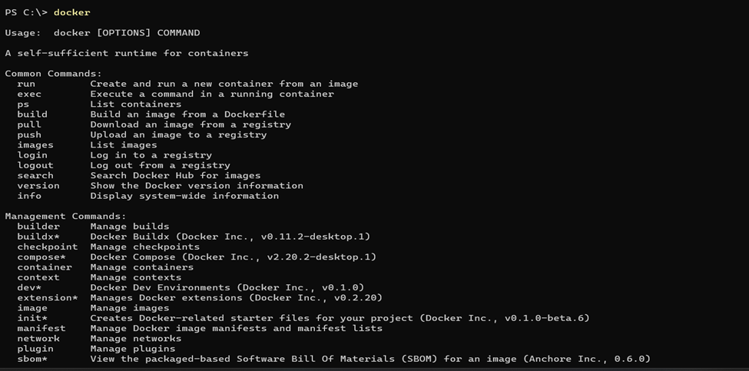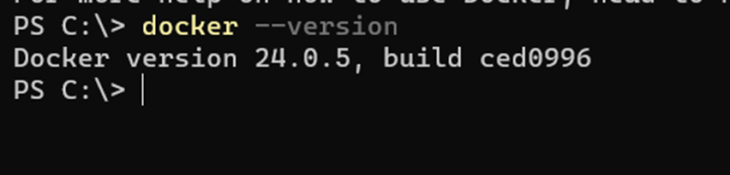**Now, create a folder named ‘Terraform Scripts’ in which we save our different types of scripts which will be further used in this experiment.**

**Step 2: Firstly create a new folder named ‘Docker’ in the ‘TerraformScripts’ folder.**

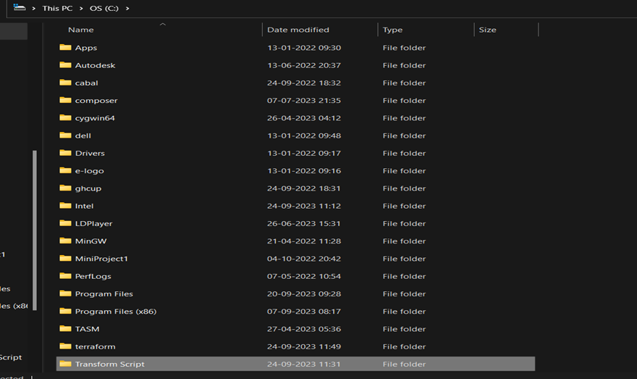

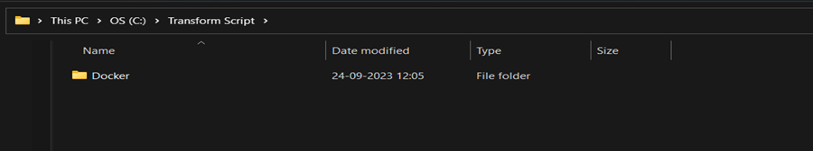

**Then create a new docker.tf file using vs code editor and write the following contents into it to create a Ubuntu Linux container.**

**Script:**

**terraform{**

**required_providers{**

**docker = {**

**source = "kreuzwerker/docker"**

**version = "2.21.0"**

**}**

**}**

**}**

**provider "docker" {**

**host = "npipe:////.//pipe//docker_engine"**

**}**

**# Pulls the image**

**resource "docker_image" "nginx" {**

**name = "nginx:latest"**

**keep_locally =false**

**}**

**# Create a container**

**resource "docker_container" "nginx" {**

**image =docker_image.nginx.image_id**

**name ="nginx"**

**}**

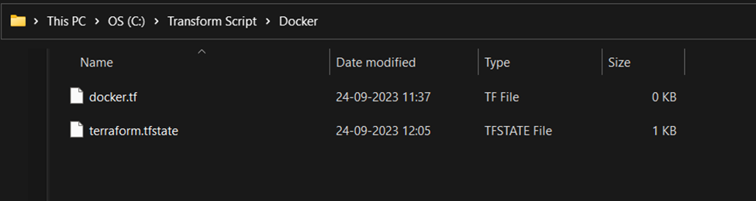

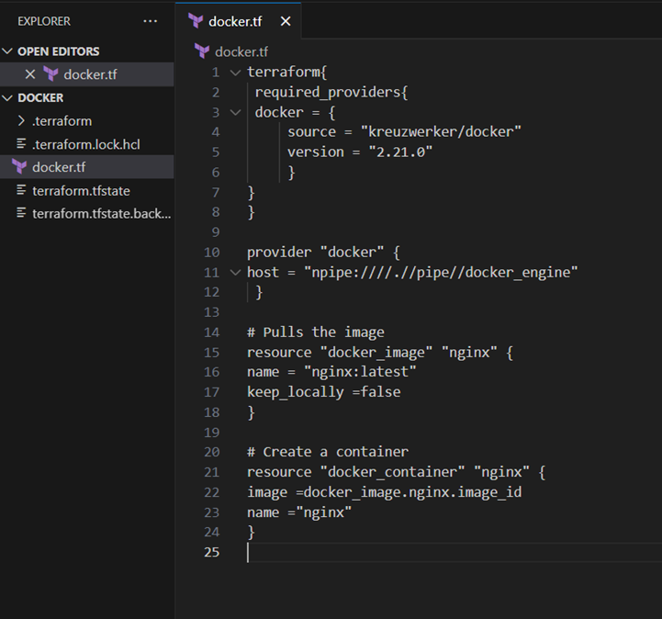

**Step 3: Execute Terraform Init command to initialize the resources**

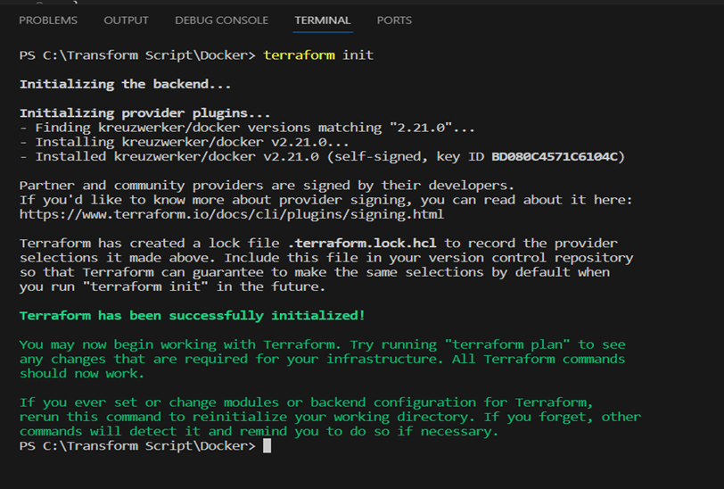

**Step 4: Execute Terraform plan to see the available resources**

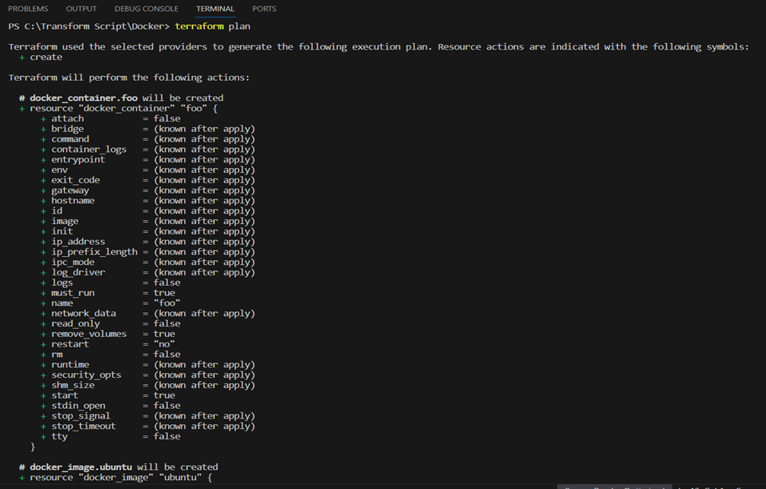

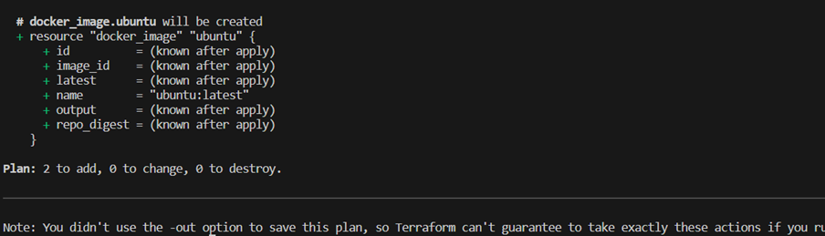

**Step 5: Execute Terraform apply to apply the configuration, which will automatically create and run the Ubuntu Linux container based on our configuration. Using command : “terraform apply”**

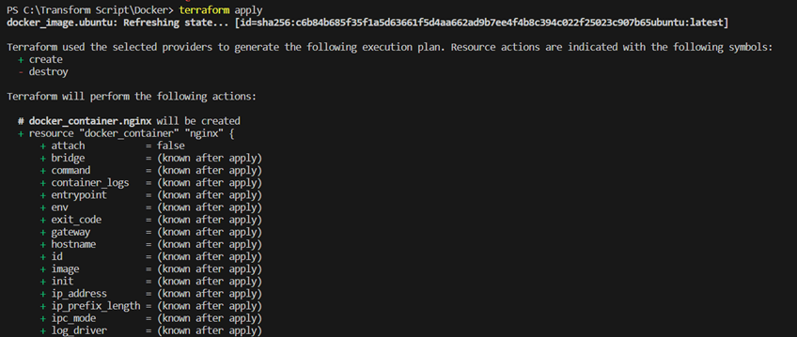

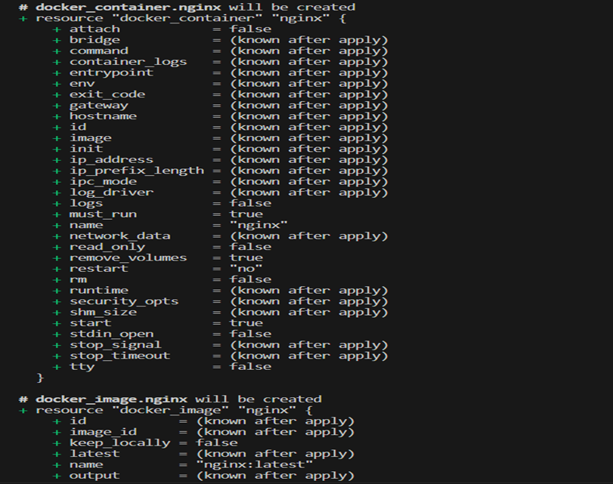

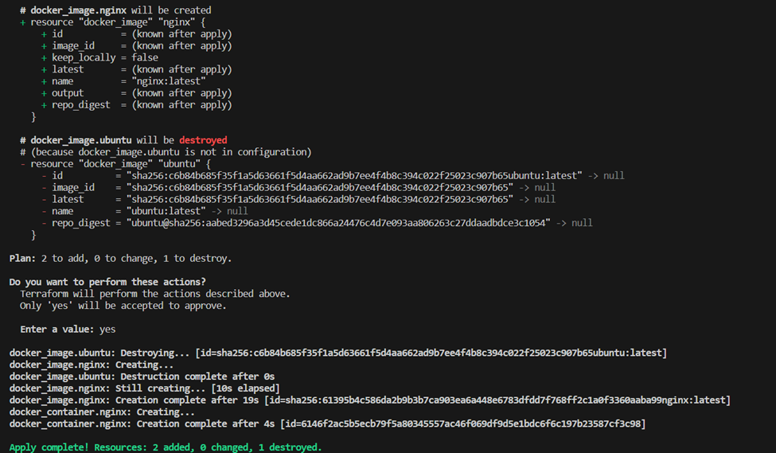

**Docker images, Before Executing Apply step:**

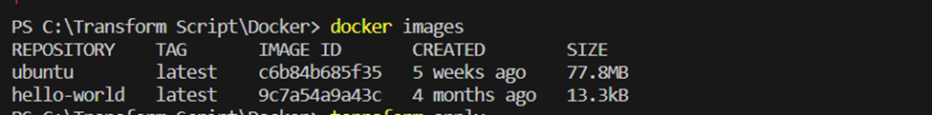

**Docker images, After Executing Apply step:**

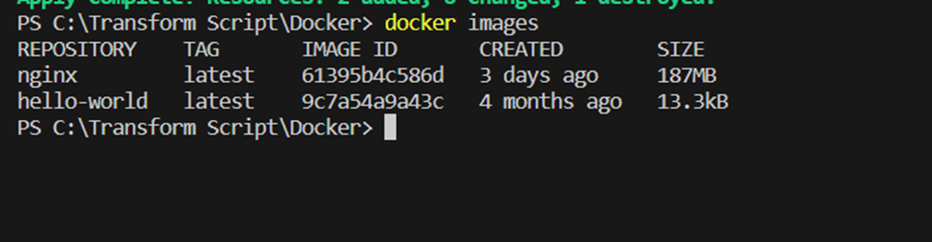

**Step 6: Execute Terraform destroy to delete the configuration, which will automatically delete the Ubuntu Container.**

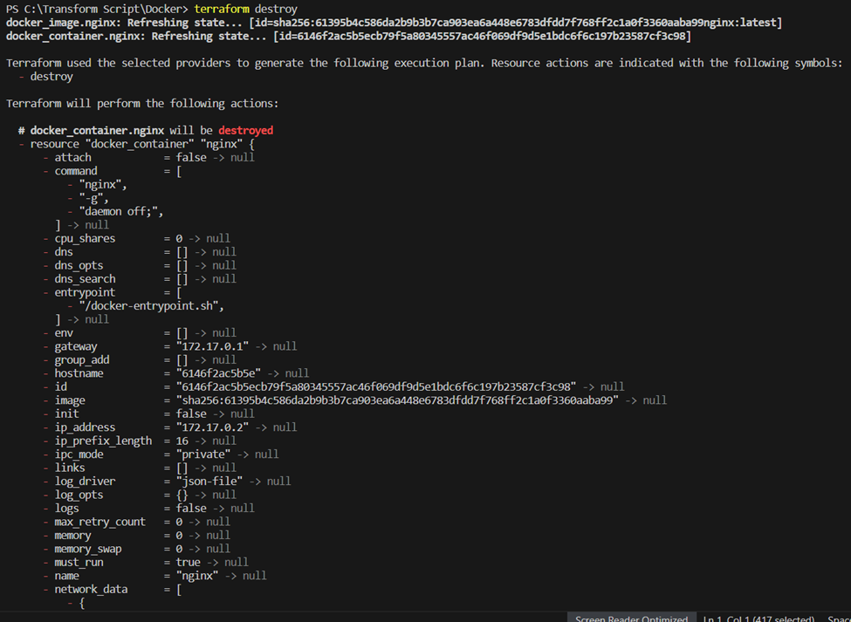

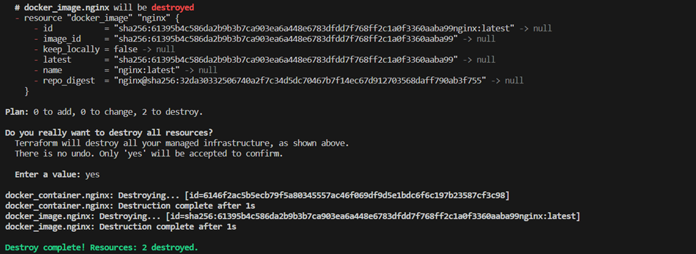

**Docker images After Executing Destroy step**

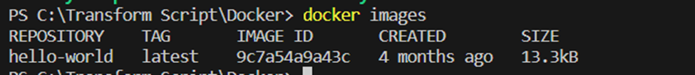

**Conclusion:**

Thus, we have successfully created a Docker image using Terraform, demonstrating the power of Infrastructure as Code (IaC). By automating the creation and management of cloud resources, Terraform simplifies deployment processes, enhances scalability, and ensures consistency across environments. The integration with Docker further improves portability and efficiency, allowing for seamless application deployment across multiple platforms.